PRACTICE GUIDE

Case notes

Case notes
Case notes provide a chronological record of the delivery of child protection services to children, their families and carers. A case note is a summary of interactions practitioners have with a child, their family, a significant person and other professionals, and should provide a contextual summary of a single interaction or activity per case note.

Accurate case notes provide relevant information for future use and ensure the availability of information, especially if there is a change in team members. For future readers (including staff or the child themselves), well written case notes add meaning to the child and family’s case history as they build a collection of records about departmental decision-making and professional assessments over time.

Case notes are recorded in ICMS. For any assistance or guidance when using ICMS, click on the ‘Help’ button on the right hand side of the ICMS homepage.

Information to record
Case notes contribute to the personal history of the child. It is essential that information recorded in case notes on ICMS are:
- complete - all relevant information is recorded, including attachments which relate to the information recorded in the case note
- current - the case note is recorded in a timely manner and information is up-to-date
- respectful - the case note is written in a manner that respects and upholds the dignity of the child, family and carer, and reflects the Framework for Practice
- meaningful - other people who read the case note can understand the context of the case note and the rationale for any decisions made.

Information in case notes is reflected in a number of applications and other programs used by Child Safety such as the CS Portal and kicbox. As such, it is important that information documented in case notes is recorded respectfully, accurately and in a timely manner.

Participants of a case note
A participant should only be added to a case note if the information being recorded relates specifically to that person. When a participant is added into an ICMS event, they can be added as a participant in a case note created in that event. The case note can be viewed via the ‘Case notes’ tab in the person record of each participant who has been added to the case note. This allows Child Safety staff to view all case notes referring to a specific person from a single location in ICMS without the need to navigate between different events.

When a case note is completed in an Ongoing Intervention (OI) event, the case note is automatically shared to the OI ‘Case notes’ tab in the associated OI events of any linked subject child in ICMS, even if the linked subject child was not included as a participant in the case note.

It is not possible to add case notes to a carer's person record. If the information being recorded relates specifically to the support or approval of, or training for, a carer during their period of approval:
- go to the carer entity
- click on the ‘Approval’ tab on the left hand side
- record the information in the ‘Monitor and support’ section.

If the case note relates to supporting a carer to maintain a child’s care arrangement, create the case note in placement event.

Categories
A category is chosen for each case note that is recorded in ICMS. It is important to choose the most relevant category when completing a case note to ensure that relevant case notes can easily be retrieved. More information about each category is provided in the ‘Choosing a category’ section at the end of this document.

The categories for case notes are:

- Case discussion / decision  - Case planning / implementation  - Communication plan / strategies in place  - Complaint  - Confidential legal advice – privileged (must not be disclosed)  - Court  - Family contact  - Financial  - Generic  - Independent entity  - Info received from QPS  - NDIS  - OI – Received concerns  - PCO – child contact  - PCO – guardian contact  - Placement  - Practice panel  - Prescribed home visit | - QCAT  - Referral  - Referral for active intervention  - Standards of care  - Support Service plan  - Tool – Circles of safety and support  - Tool – Collaborative assessment and planning framework  - Tool – Safety and support planning  - Tool – Family roadmap  - Tool – The future house  - Tool – The immediate story  - Tool – Safe contact  - Tool – The safety house  - Tool – The three houses  - Transfers  - Victim of crime  - Visit to carer  - Visit to child  - Visit to parent

Location in ICMS
The events in ICMS reflect the child protection continuum. Case notes can be added into any open event, or via the ‘Case notes’ tab when the event is closed.

Record case notes relevant to multiple children within the same family in the event for the oldest child, with the other children included as participants in the case note.

The ‘Case notes’ tab is a separate tab used to display the case notes associated with the event being viewed. The tab displays the following information depending on the type of event, as outlined below.

In an OI event, the ‘OI case notes’ tab displays:

- case note type – describes the type of case note and provides a link to the case note
- event – if there is more than one OI event open for the child, the event number that the case note belongs to is shown
- status – whether the case note is new, in progress or complete
- date – the date of the event or interaction (retrieved from the date box at the bottom of the case note form).
Below is an example of what may display in an ‘OI case notes’ tab:
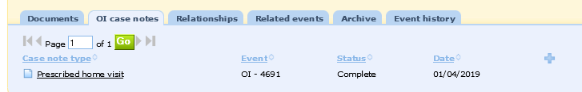
In an Intake, Investigation and assessment (including Standards of Care), Placement or Court event, the ‘Case notes’ tab displays:

- case note type – describes the type of case note and provides a link to the case note
- summary – this is the title of the case note (as typed into the description field within the case note)
- date – the date of the event or interaction (retrieved from the date box at the bottom of the case note form).

Below is an example of what may display in a ‘case notes’ tab:

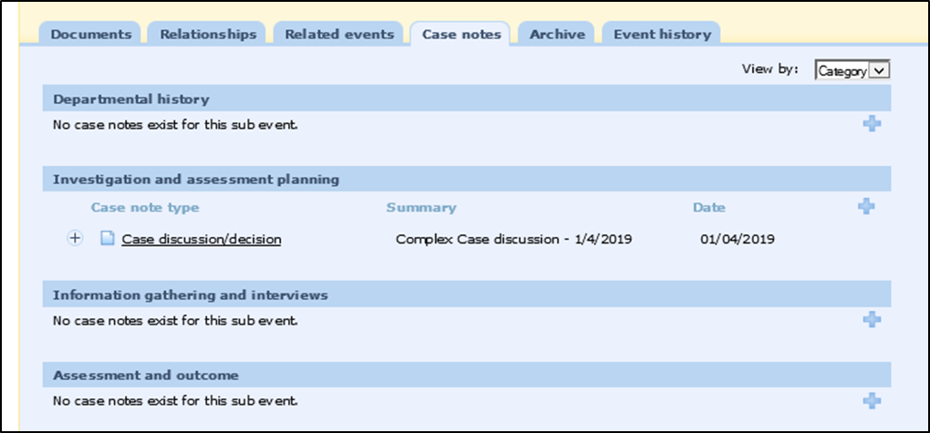

Searching
A brief summary of the case note can be viewed by hovering the curser over the specific case note.

By clicking on the ‘Case notes’ tab on a person profile, all case notes where that person has been listed as a participant, across all events, can be viewed. To search for a case note in this view, the following filters can be used:

- created by – using ‘any officer’ or the name of the person who created the case note
- date from – using a preferred date range
- case note type
- keywords – using any words contained in the case note being searched for
- event type – Investigation and assessment, OI etc.
- form status – new, in progress, complete, or any status
- created at office – using the name of the CSSC where the case note was created.

The following case note search is filtered by the event type of ‘Investigation & assessment’:
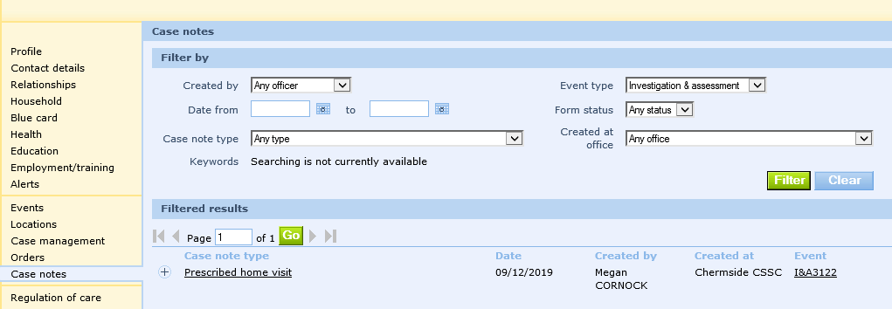

Using the filter ‘case note type’ can help identify when a CSO last visited a child. The following case note search is filtered by the case note type of ‘Prescribed home visit’:
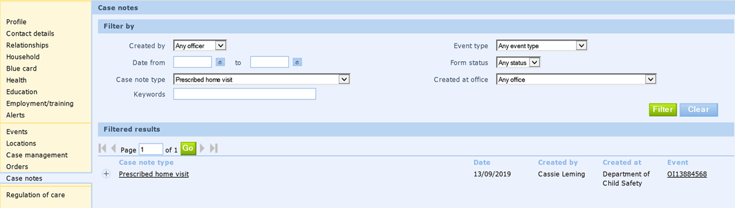

Choosing a category
The following table lists the case note types available in ICMS and the most relevant events to record them in. Attach any supporting documentation relating to the case note to the person’s relevant ICMS event.

Category | Information to be recorded | Event
 |  | Intake | I&A | OI | Placement | Court
Case discussion / decision | Significant discussions/decisions impacting on the direction of a case or case outcome, including the decision, the rationale and who made the decision. For example:  - complex case discussions  - case consultations  - informal consultations with colleagues  - any discussion held where significant information is exchanged or shared and decisions are made. | ✓ | ✓ | ✓ | ✓
Case planning / implementation | Details of interactions with the child, parent, service provider or significant person as it relates to planning for and meeting the goals and outcomes of the case plan. For example:  - implementation of the case plan  - planning for a family group meeting  - planning for a review meeting  - feedback obtained from services regarding case plan goals and actions  - actions taken by a CSO to achieve case plan goals. |  | ✓ | ✓
Communication plan/strategies in place | Information about communication plans relating to a parent or child, including:  - strategies that have been put into place to manage identified challenges impacting on communication  - a communication plan between a parent / young person and Child Safety  - meetings to develop or review a communication plan. |  | ✓ | ✓ | ✓
Complaint | Details of complaints and the processes of complaints made and responded to by the service centre in day-to-day case management.  As per the complaints policy, record as much information as possible to demonstrate that the complaint has been appropriately dealt with, including:  - the name of the complainant  - details of the complaint  - how the complaint was managed  - who managed the complaint  - any follow-up processes to occur. | ✓ | ✓ | ✓ | ✓
Confidential legal advice – privileged (must not be disclosed) | This case note type is only to be used by Legal Officers. Legal privilege applies when a case note is written by a lawyer and contains legal advice. The case note is then not subject to disclosure rules.  It is the role of the OCFOS lawyer to record legal advice they have provided to CSSC staff. CSSC staff who receive advice from an OCFOS lawyer are not to record their summary of the advice received, as this will not be protected by legal professional privilege.  Reference to the existence and content of legal advice may also result in waiver of the privilege. Do not directly reference or quote legal advice outside Child Safety, without approval from the source of the advice, either OCFOS or Legal Services Branch. |  | ✓ | ✓ |  | ✓
Court | Information regarding activities that relate to child protection court proceedings, including.  - when a copy of an order was given to the respondent  - discussion with the respondent parent/s regarding their right of appeal, duration of the order  - court dates, times and adjournments. |  |  | ✓ |  | ✓
Family contact | Information about when a child has contact with family members or significant people, including:  - face to face visits, telephone / facetime calls, SMS, letters and emails  - decisions relating to family contact, including the child’s view and who participated in the decision making  - observations made during contact  - any worries that disrupted contact and how they were responded to. |  | ✓ | ✓
Financial | Information relating to financial interactions or claims, such as:  - child related costs  - support packages  - fortnightly caring allowance  - a child's bank account or financial matters. |  | ✓ | ✓ | ✓
Generic | Other activities not easily categorised.  This case note is ONLY to be used in limited circumstances. | ✓ | ✓ | ✓ | ✓ | ✓
Independent entity | Used to record additional detail relating to the independent person for a child and family that is not captured in the independent person form, including:  - Discussions with the child and family about their option to have an independent person, including at court.  - Discussion and information provided to a person nominated to be the independent person.  - Information considered and rationale for the senior team leader’s decision regarding suitability of an independent person.  - Discussion with the independent person.  - Detail regarding an independent person’s participation in a meeting.  - Response to DCPL regarding a person’s suitability to be an independent person. |  | ✓ | ✓ | ✓
Info received from QPS | Information sought and received from the QPS, including:  - occurrence reports  - criminal or domestic violence history.  Attach or reference the information received from the QPS. | ✓ | ✓ | ✓ | ✓
Interstate information | Information about accessing Connect for Safety. | ✓ | ✓ | ✓ | ✓
NDIS | Information about NDIS for a child or young person with disability, including:  - their NDIS application  - NDIS approvals  - NDIS provision of services  - NDIS meetings  - NDIS funding. |  | ✓ | ✓ | ✓
OI – received concerns | Concerns received about a child subject to OI that:  - do not meet the threshold for a notification  and  - do not relate to the standards of care being provided.  Include details about:  - the rationale for the concerns not reaching the threshold for a notification  - any consultations held  - the person providing the information being a notifier, so they are afforded protection in line with the Child Protection Act 1999, section 186A.  Refer to Procedure 1 Record new child protection concerns for further information. |  |  | ✓
PCO – child contact | Details of contact with a child subject to a permanent care order, such as a visit or phone call. |  |  | ✓
PCO – guardian contact | Details of contact with the guardian of a child subject to a permanent care order, such as a visit or phone call. |  |  | ✓
Placement | Information relating to the child’s care arrangement, including:  - the type of care needed  - placement matching  - placement meetings  - emails and discussions about placement options. |  | ✓ | ✓ | ✓
Practice panel | Information relating to planning for and conducting practice panels, including:  - a summary of invitations  - agendas  - discussion / minutes  - follow up actions. |  | ✓ | ✓
Prescribed home visit | Details of visits to a child (in care) or a child and their parents (for in-home cases), that meet the requirements of a minimum face-to-face contact. Refer to the Child Safety Practice Manual for minimum face-to-face contact requirements for in-home, reunification and non-reunification cases.  Note: To record visits to a parent, refer to ‘Visit to parent’ case note type. |  |  | ✓
QCAT | Information about QCAT proceedings. |  | ✓ | ✓ | ✓ | ✓
Referral | Referrals offered or completed for the child or parent, including contact with the agency to discuss:  - whether the services provided would meet the child’s or family’s identified needs  - whether the child or family is eligible for the service  - availability of services and timeframes for commencement and completion of the service  - expectations for how often the agency will work with the family  - feedback and review of progress  - the cost of the service and any other resources required to complete the work with the child or family. | ✓ | ✓ | ✓
Referral for active intervention | Obsolete - do not use this case note type.
Standards of care | Information relating to:  - preliminary conversations and actions in response to potential concerns that, if not addressed may lead to a formal SOC process (a continue monitoring the SOC response / SOC review / SOC harm report)  - actions in relation to ongoing monitoring of the standards of care after a SOC process.  This case note type is also used by RIS/CSAHSC to record concerns about the quality of care provided to a child, or about harm to a child in care, for action by the relevant CSSC. | ✓ |  |  | ✓
Support service plan | Key information about the development of the support plan, not captured in the plan.  Attach the completed support plan to the case note. |  |  | ✓
Tool – Circles of safety and support | Information about the use of the ‘Circles of safety and support’ tool with a child, young person or family. |  | ✓ | ✓ | ✓
Tool – Collaborative assessment and planning framework | Information about the use of the ‘Collaborative assessment and planning framework’ tool with a child, young person or family. |  | ✓ | ✓
Tool – Safety and support planning | Information about the use of the ‘Safety and support planning’ tool with a child, young person or family. |  | ✓ | ✓
Tool – Family roadmap | Information about the use of the ‘Family roadmap’ tool with a child, young person or family. |  | ✓ | ✓
Tool – The future house | Information about the use of the ‘Future house’ tool with a child, young person or family. |  | ✓ | ✓
Tool – The immediate story | Information about the use of the ‘Immediate story’ tool with a child, young person or family. |  | ✓ | ✓
Tool – Safe contact | Information about the use of the ‘Safe contact’ tool with a child, young person or family. |  | ✓ | ✓
Tool – The safety house | Information about the use of the ‘Safety house’ tool with a child, young person or family. |  | ✓ | ✓
Tool – The three houses | Information about the use of the ‘Three houses’ tool with a child, young person or family. |  | ✓ | ✓
Transfers | Information about a case transfer between CSSCs, including:  - communication between CSSCs regarding the transfer  - the date paper files and other relevant information are transferred. |  | ✓ | ✓
Victim of crime | Information about a child, young person or parent who is or may be a victim of crime, including:  - information provided to a family  - consent provided  - applications  - eligibility processes.  Refer to procedure 7 Victim Assist Queensland. | ✓ | ✓ | ✓
Visit to carer | Summary and outcome of a visit to a carer regarding a child and their care arrangement, including:  - support provided to the carer for the child and their care needs  - support and monitoring of activities outlined in the placement agreement  - issues impacting on the progress of the child’s case plan. |  | ✓ | ✓ | ✓
Visit to child | Summary and outcome of a visit to a child that does not meet the requirements of a face-to-face contact in the Child Safety Practice Manual.  For a child subject to an investigation and assessment, including a child subject to an assessment care agreement or court assessment order, record home or other visits to the child.  Note: Details of interviews for assessment purposes are recorded in the Record of interviews form.  Record:  - a summary and outcome of the visit to the child  - phone calls, emails, or other contact with a child or young person  - a home visit to a child completed by a non-authorised officer  - an attempt to do a prescribed home visit to a child if the visit is ‘unsuccessful’ (for example, the child was not sighted). |  | ✓ | ✓ | ✓
Visit to parent | Summary and outcome regarding a visit or attempted visit with a parent, including:  - visits to parents in line with face-to-face contact requirements whose children are not residing in the home  - visits to a child and family subject to an in-home case where the child was not home at the time, but discussions were held with the parents  - phone calls, emails, or other contact in an attempt to visit a parent. |  | ✓ | ✓

Version history
Published on: | January 2022
Last reviewed: | November 2022
Owner: | Office of the Chief Practitioner

